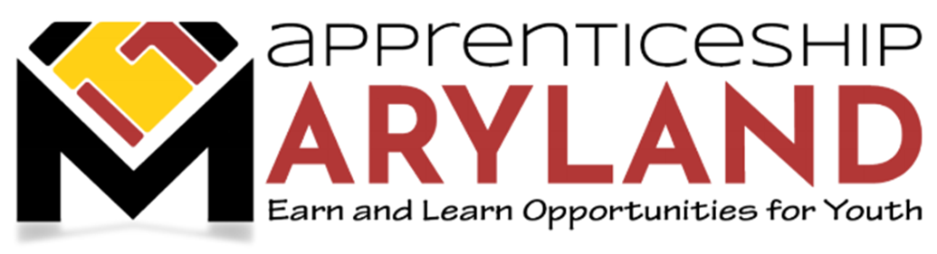
Youth Apprenticeship Advisory Committee
November 16, 2022 Meeting
Agenda

- Welcome and Introductions and Recognition of National Apprenticeship Week 2022

- Approval of Minutes

- Discussion Regarding Status of Apprenticeship Maryland Program (AMP)

- Review statistics from Current Youth Apprenticeship Program Overview document (attached)
- Current AMP youth apprentices by industry of focus
- Current average hourly wage
- Current 2022-2023 Registrations

- MSDE Update – 2022-2023 School Year Information

- Policy Update – Status of Policy Development Process

- Legislative Update – N/A

- Marketing Update – SAE 2020 Supported Statewide Marketing Campaign

- Other Business

