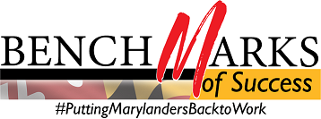

WIOA Alignment Group Meeting
Monday, January 27, 2020, 1:00 – 4:00 PM
Call-in #: 662-762-0362 / Access Code: 415-623-772#
Part 1: Combined Meeting of WIOA Alignment Group and Committee Leadership Teams
I. Welcome and Introductions Lauren Gilwee
II. Committee Report Outs
- Overview Natalie Clements
- Communications Committee Susan Kaliush, Kimberlee Schulz, and LiLi Taylor
- Data and Dashboard Committee Douglas Weimer, Milena Kornyl, and Natalie Clements
- Policy Committee Lauren Gilwee and Natalie Clements
- Professional Development and Technical Assistance John Feaster
III. Next Steps and Action Items Natalie Clements

Part 2: WIOA Alignment Group – Remaining Business
I. Executive Steering Committee Updates Lauren Gilwee
II. State and Local Plans Lauren Gilwee
III. SNAP/ABAWD Final Rule Jacqueline Tina Turner and Augustin Ntabaganyimana
IV. Raising the Bar 2020 Planning Walter Simmons and Becca Webster
V. Legislative Updates All
VI. Strategic Planning for the PD/TA Committee John Feaster

Next Meeting: Monday, February 24, 2020

