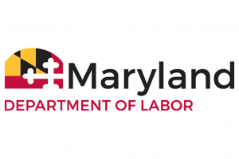
DIVISION OF LABOR AND INDUSTRY
Office of the Commissioner
1100 North Eutaw Street, room 600
Baltimore, Maryland 21201

AMUSEMENT RIDE SAFETY ADVISORY BOARD Meeting
Monday, October 26, 2020
10:00 a.m.
(Virtual meeting)

AGENDA

1. Meeting Called to Order – Glenn Fishack, Sr.
2. Introductions
3. Approval of the minutes from the Wednesday, March 11, 2019 board
meeting
4. Program Update – Jim Harper
5. Regulations-
Challenge Courses Adoption
- Presentation
- Discussion
6. Other Business
7. Adjournment

